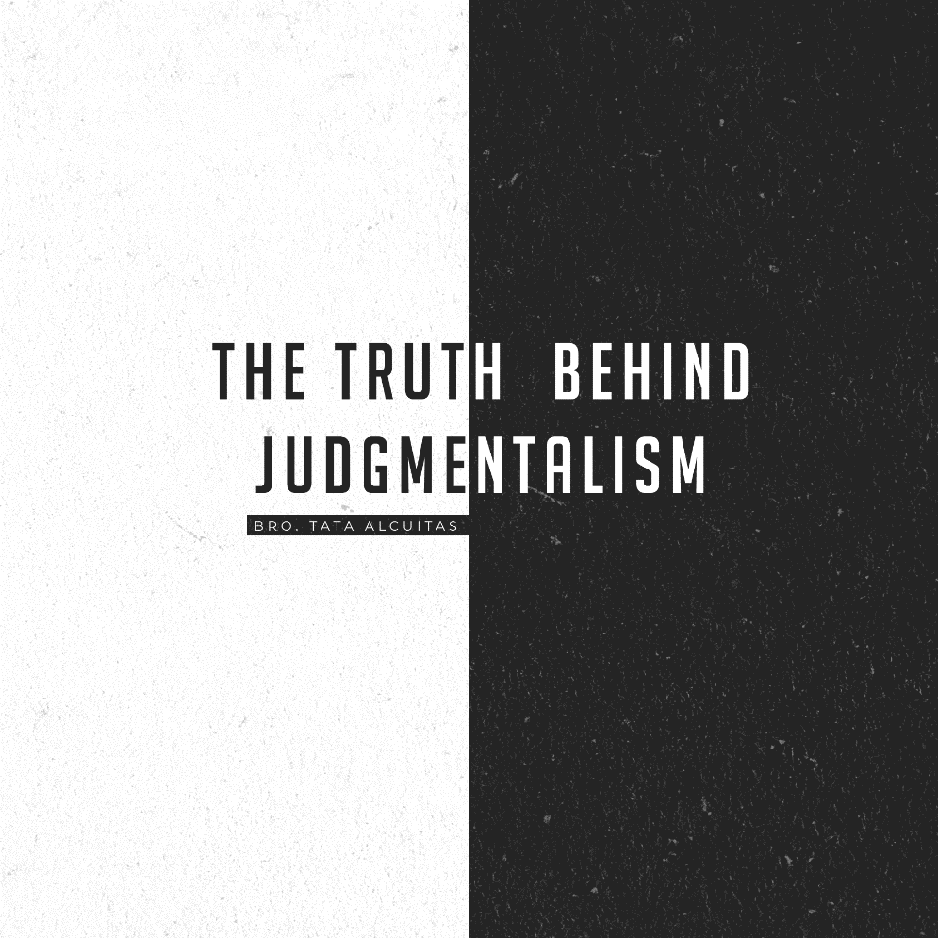

All of us are guilty of this sin without even knowing it. This sin is what Jesus mentioned more often, more severely, and more directly than any other sin. It wasn't adultery, it wasn't taking drugs, it wasn't watching TV. But it was the sin of self-righteousness. You can find it anywhere. Whether you're rich or poor, educated or uneducated, Christian or non-Christian. This sin of self-righteousness leads us to judge others unrighteously. It's one sin we tend to make excuses for. Oftentimes, we are guilty of both sins of judging hypocritically and failure to judge righteously.

Some preachers are leaning towards judging while others are totally against judging others. Mat. 7:1 tells us “Don’t judge or you too will be judged.” On the other hand, John 7:24 tells us “Stop judging by mere appearances, but instead judge correctly.” That means we can also judge righteously. To understand, we must look at the Bible in totality. We can’t just pull out one text or another and prove our point. That’s why these books in the Bible are so important. They are a concordance and a topical Bible. Read the verses before and after the text so that it cannot be taken out of context.

**RIGHTEOUS JUDGEMENT**

John 7:24 ”Stop judging by mere appearances, but instead judge correctly.”

Jesus is not telling us to abandon judgment. That would make sense because you have to judge evil from good. You have to judge darkness from light. John 7:24 destroys the doctrines of devils that tell us we are wrong for judging righteously. The enemy doesn’t want you to know that it is biblical to judge. As a matter of fact, John the Baptist judged righteously. Ezekiel judged righteously. So if it’s wrong to judge righteously, why did God tell Ezekiel in Ezekiel 22:2“Son of man, will you judge her? Will you judge this city of bloodshed? Then confront her with all her detestable practices to me. God tells Ezekiel to judge His people. Ezekiel’s assignment was to show God’s people their abominations.

So is it wrong to call out abominations? Is it wrong to call out sins? God commanded Ezekiel to call out His people’s sins. Without judgment, it’s impossible to know evil from good or to preach against wickedness.

As Christians, we should have discernment when looking at circumstances. Like today, they call evil good and good evil. Amos 5:15 says, “Hate evil, love good, maintain justice in courts. Perhaps the Lord God Almighty will have mercy on the remnant of Joseph”. So if it’s wrong to judge, why does the word of God says hate evil and love good? I’m telling you the word of God is destroying the doctrine of devils that throws up “judge not” every time we take a stand against sin. They take what Jesus said in Matthew 7:1 “Do not judge, or you too will be judged” out of context. Why would Jesus tell us not to judge and in John 7: 24 He said judge righteous judgment? It sounds like He is contradicting Himself.

“Judge not or you too will be judged” is probably one of the better-known verses to the unbeliever. And it is used by all sorts of people Christian and non-Christian alike to accuse individuals of wrongly being judgmental. “How dare you say my actions, my lifestyle, my choices are sinful? Didn’t Jesus say “do not judge”? But if you keep reading Matthew 7, you will discover that Jesus is talking about a different type of judgment. He is not talking about righteous judgment. Jesus is talking about hypocritical judgment. There is no analysis, evaluation, or discernment involved here but simply to pass a verdict or condemn, in other words, judging unrighteously.

**HYPOCRITICAL JUDGMENT**

Jesus’ statement “do not judge” is speaking against the kind of hypocritical judgmental attitude that tears down others in order to build ourselves up. It is not a blanket statement against all critical thinking which needs to be done in assessing certain situations. The enemy isolates Chapter 7 and verse 1 from the context, to make it sound like Jesus was saying “Never judge”. Matthew 7:3-5. 3 says, “Why do you look at the speck of sawdust in your brother’s eye and pay no attention to the plank in your own eye? 4 How can you say to your brother, ‘Let me take the speck out of your eye,’ when all the time there is a plank in your own eye? 5 You hypocrite, first take the plank out of your own eye, and then you will see clearly to remove the speck from your brother’s eye.

It’s clear. Jesus is talking about hypocritical judgment. He is teaching His disciples to be different from the Pharisees because they judge according to appearance. Matthew 7:15 says, “Watch out for false prophets. They come to you in sheep’s clothing, but inwardly they are ferocious wolves. Matthew 7:20 - “Thus, by their fruit you will recognize them.” Jesus is saying here judge their fruit. You will know a false prophet, a false teacher, or a person in general by their fruit. If they bring forth corrupt fruit then the tree is what? Corrupt! So Jesus is not teaching against judging righteously. It’s impossible to know if a fruit is good or corrupt without judging. So now, if Jesus tells us not to abandon judgment, if we are called to judge the truth according to God’s word, when is it wrong to judge? Listen here church as I’m going to present to you the reasons why the judgment game is a dangerous spiritual game. As I read them, I said to myself, it is better not to judge at all but together we will practice righteous judgment, at the same time avoid hypocritical judgment at all costs.

Just a word of caution for Christians, as we have already read the word of God from cover to cover, presumably we have known the truth, but sadly, we also have the tendency to become self-righteous. This is something we have to be cautious about because when we become self-righteous, we think we’re not so bad, we think we have few faults and weaknesses but we’re alright. A self-righteous person accuses others but excuses himself. He measures other people by the wrong standard, usually comparing others to himself as the better one. Finally, a self-righteous person usually misinterprets God’s blessing in his life for he thinks he deserves God’s blessings.

He doesn’t realize it’s all of God’s grace because if God gave him what he really deserved he wouldn’t even be here. And when we are self-righteous, it is easy to fall into rendering a hypocritical judgment or unrighteous judgment.

**When Is It Wrong To Judge or When Do We Commit Hypocritical Judgment?**

1. It's wrong to judge when you practice the same sin. Romans 2:1-3. “You therefore have no excuse, you who pass judgment on someone else, for whatever point you judge the other, you are condemning yourself, because you who pass judgement do the same things. 2. Now we know that God’s judgment against those who do such things is based on truth.3 So, when you, a mere man, pass judgment on them and yet do the same things, do you think you will escape God’s judgment?

2. When it blinds you to your own faults. Matthew 7:1-3 "Do not judge or you too will be judged. For in the same way you judge others, you will be judged and with the same measure you use, it will be measured to you "Why do you look at the speck of sawdust in your brother's eye and pay no attention to the plank in your own eye?"

3. It's wrong to judge when you draw conclusions based on outward appearance or external observances. John 7:24. "Stop judging by mere appearance and make a right judgement."

4. It's wrong to judge when you condemn somebody else before hearing the facts. John 7:51 "Does our law condemn a man without first hearing him to find out what he's been doing?"

5. It's wrong to judge when it causes you to speak evil against, or slander, another believer. James 4:11-12 "Brothers, do not slander one another. Anyone who speaks against his brother or judges him speaks against the law and judges it. And when you judge the law you're not keeping it but setting in judgement on it. There is only one law giver and judge, the one who is able to save and to destroy, but you, who are you to judge your neighbour?"

**CONCLUSION:**

There are appropriate and inappropriate times and ways to judge others. Christ though instructs us to pay more attention to our own faults than to judge the faults of others. Oftentimes our judging leads to turning others away from God, which is very sad. It is not our place to judge others for we do not know a person’s heart or true intention and when we do judge, it is oftentimes out of pride, a result of wrong information, or not enough facts. We are not meant to judge others, we are meant to love others as Christ would that we may lead them to Christ and not away.

But when we are called to judge the truth according to God’s word, we are to do it with a sense of humility, not an air of superiority. If we know what’s best for others, we know God’s word. But in humility that says “I know I am not perfect either but together we can help challenge and move each other through God’s word to being more like Him.” His word is always the measuring tool, not our life.

You are not called to live up to the example of your mother or father, or even your idol, no matter how good of an example they are. You are called to live up to the word of God as manifested in the life of Christ. Remember, we are to judge the sin and love the people involved. I know it is very hard to do, it’s always been easier said than done because we often connect the mistake to its doer but practice makes perfect.

A criminal was about to be released not because he is innocent but because of a technicality. As the judge prepared to release him, he said to this man “I know that you are guilty and you know it. And I want you to remember that one day you will stand before a better and wiser judge, and there you will be dealt with according to justice and not according to law.”

**LIFE GROUP DISCUSSION:**

**1) What kind of attitude should we have about judging?**

**2) How do we balance confronting people with their sins and the fact that God is THE judge?**

**3) Can you share about a time when you were treated unjustly or judged incorrectly? Or, when have you mistakenly misjudged someone?**